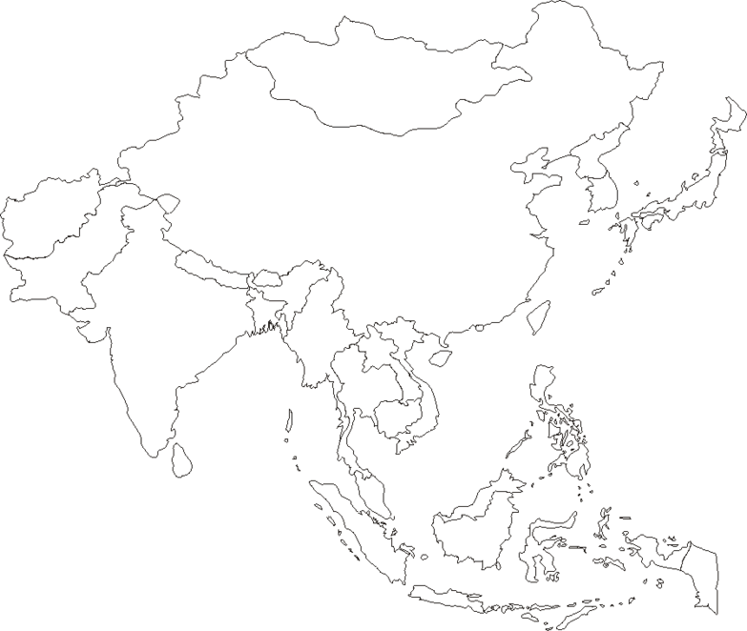

Know:

India S. China Sea

Nepal Indian Ocean

Bhutan Philippine Sea

Bangladesh Himalayas

Japan Sri Lanka

China Taiwan

Mongolia

North Korea

South Korea

Tokyo



Know:

India S. China Sea

Nepal Indian Ocean

Bhutan Philippine Sea

Bangladesh Himalayas

Japan Sri Lanka

China Taiwan

Mongolia

North Korea

South Korea

Tokyo