Services in Rural vs. Urban Settlements

Match the following words to the correct picture:
- Circular Rural Settlement
- Linear Rural Settlement
- Dispersed Rural Settlement

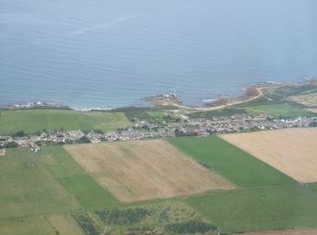

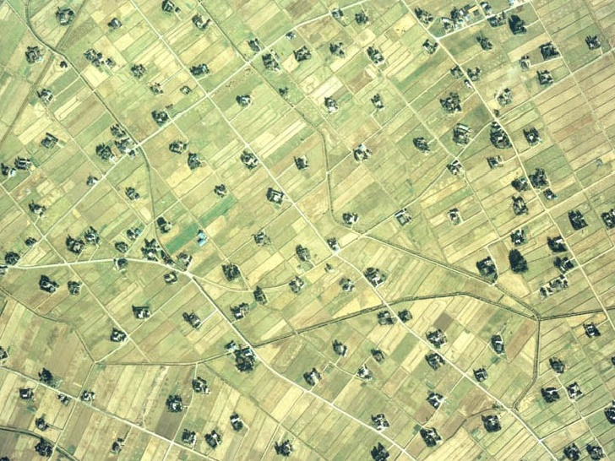
____________________________________________________________

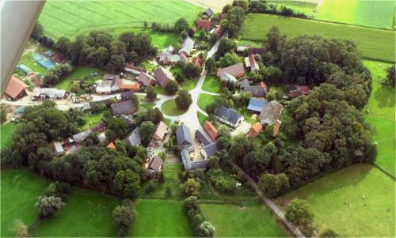

- Circular and linear rural settlements are examples of ___________________________________________________rural settlements.

- What is the difference between clustered and dispersed rural settlements?

- Where were dispersed rural settlements the most common?

- What was the Enclosure Movement and what were its advantages? What happened to villagers who were displaced from farming?

- What is urbanization?

- What are the three main differences between urban and rural settlements?

