2017 AP HUMAN GEOGRAPHY SAMPLE FREE RESPONSE QUESTION
Directions:
You have 25 minutes to complete the following question. It is suggested you take up to 5 minutes of this time to plan and outline your answer. While a formal essay is not required, it is not enough to answer the question by merely listing facts. Illustrate your answer with examples where appropriate. Be sure that you number your answer, including individual parts as the question is numbered below.
STEPS TO TACKLING THIS FRQ:
- Read the entire FRQ.
- Underline all directive words.
- Make a brief outline of what you will write. This can be done using brainstorming and bullet format.
- Complete the FRQ
- As you write: When you complete any sentence/thought ask yourself how, when, where, what, and why to thoroughly answer the question.

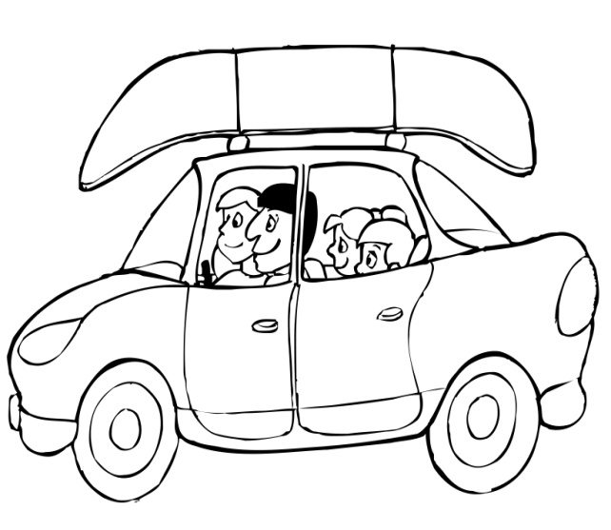
X Y

In 1972, “School’s Out for Summer” became Alice Cooper’s first major hit reaching #7 in the Billboard Top 100 Pop Singles. Each year thousands of school-age children look forward to summer vacation.
A. Define the term “Summer Vacation”.
B. Identify and discuss TWO things you did over summer vacation.
C. Choose either activity X or activity Y and explain how this relates to what you like to do over summer vacation and your plans for next summer vacation.

