Chapter 13 – The Humanized Environment: Key Issue 2
How Have Humans Altered Earth’s Environment?
Fouberg pp. 386-394

WATER

1. Define renewable resources:

2. Define nonrenewable resources:

3. How have the following areas been affected by a shortage of water?
CALIFORNIA | FLORIDA

4. What is the hydrologic cycle?

5. What are some of the arguments that physical geographer Jamie Linton has towards the hydrologic cycle?

6. Describe the situation and the conflict over water use between Israel & Palestine
DESCRIPTION | WATER SOURCE | CONFLICT
7. Using figure 13.12 & the blank map on the right, identify all
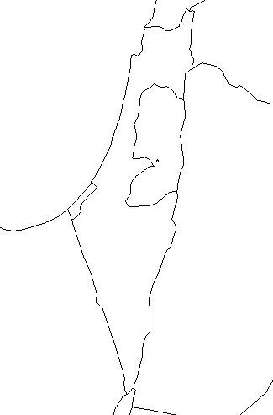
of the countries in the Middle East and trace the water pipelines that exist.

ATMOSPHERE

8. In the chart below, describe the areas where changes have been taking place in our earth’s atmosphere.
DESCRIPTION OF CHANGES
CLIMATE CHANGE

EXTREME WEATHER EVENTS
ACID RAIN

THE LAND

9. In the chart below, describe the areas where changes have been taking place in our earth’s atmosphere.
DESCRIPTION OF CHANGES
DEFORESTATION

SOIL EROSION

WASTE DISPOSAL

BIODIVERSITY
10. Define biodiversity:

11. Human impacts on ___________________________________ have increased over time. The domestication of animals, followed by the __________________________________________ of plant life, caused significant changes in our relationship with other species.

12. Humans have also _____________________________________ to extinctions.
HUMAN TRAVEL | HUMAN INTRODUCED SPECIES

